**VB PRACTICAL:-**

**1.) Write a program in vb.net to create a simple calculator. Draw below design and implement.**

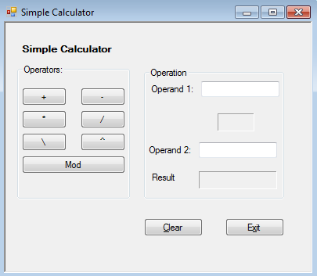

**Code:-**

Public Class Form1

Private Sub Button1_Click(sender As System.Object, e As System.EventArgs) Handles Button1.Click

Dim A As Double

Dim B As Double

Dim result As Double

A = Double.Parse(TextBox1.Text)

B = Double.Parse(TextBox2.Text)

result = A + B

lbl.Text = "+"

TextBox3.Text = result.ToString("N")

End Sub

Private Sub Button2_Click(sender As System.Object, e As System.EventArgs) Handles Button2.Click

Dim A As Double

Dim B As Double

Dim result As Double

A = Double.Parse(TextBox1.Text)

B = Double.Parse(TextBox2.Text)

result = A - B

lbl.Text = "-"

TextBox3.Text = result.ToString("N")

End Sub

Private Sub Button3_Click(sender As System.Object, e As System.EventArgs) Handles Button3.Click

Dim A As Double

Dim B As Double

Dim result As Double

A = Double.Parse(TextBox1.Text)

B = Double.Parse(TextBox2.Text)

result = A * B

lbl.Text = "*"

TextBox3.Text = result.ToString("N")

End Sub

Private Sub Button4_Click(sender As System.Object, e As System.EventArgs) Handles Button4.Click

Dim A As Double

Dim B As Double

Dim result As Double

A = Double.Parse(TextBox1.Text)

B = Double.Parse(TextBox2.Text)

result = A / B

lbl.Text = "/"

TextBox3.Text = result.ToString("N")

End Sub

Private Sub Button5_Click(sender As System.Object, e As System.EventArgs) Handles Button5.Click

Dim A As Double

Dim B As Double

Dim result As Double

A = Double.Parse(TextBox1.Text)

B = Double.Parse(TextBox2.Text)

result = A Mod B

lbl.Text = "mod"

TextBox3.Text = result.ToString("N")

End Sub

End Class

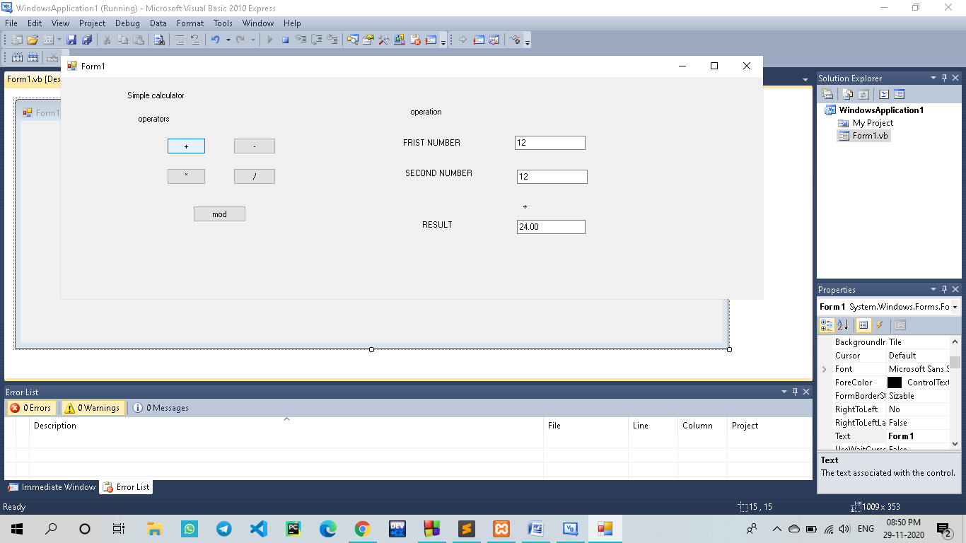

**2. Write a program in vb.net to How to Reverse Set of Numbers.**

### Code:-

Module Module1

Sub Main()

Dim no, rev, temp As Integer

Console.WriteLine("enter the no")

no = CInt(Console.ReadLine())

rev = 0

temp = no

While temp > 0

Dim t As Integer

t = temp Mod 10

rev = rev * 10 + t

temp = temp / 10

End While

Console.WriteLine("Reverse number=>" + rev.ToString())

Console.ReadKey()

End Sub

End Module

### Output:

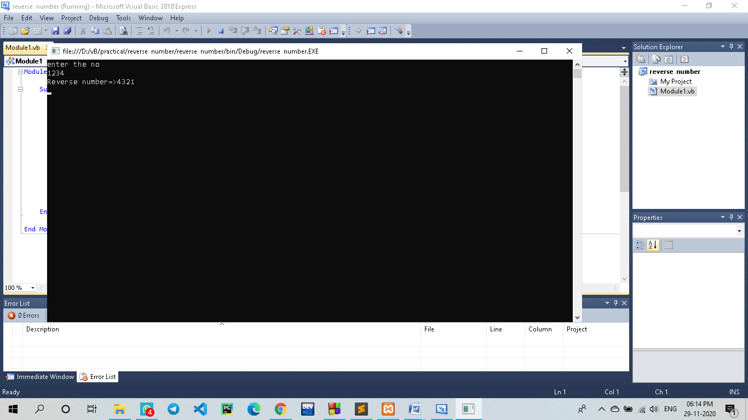

### 3.)Write a Vb.net program to design the following form, select the question number from combo box that question will be displayed into textbox and the options for that question will be displayed on four radio buttons, select option and click on submit button result should be displayed in another textbox.

### Code:-

Public Class Form1

Private Sub ComboBox1_SelectedIndexChanged(ByVal sender As System.Object, ByVal e As System.EventArgs) Handles ComboBox1.SelectedIndexChanged

If ComboBox1.SelectedItem() = "Question 1" Then

RichTextBox1.Text = "What is Capital Of India ?"

RadioButton1.Text = "Delhi"

RadioButton2.Text = "Pune"

RadioButton3.Text = "Mumbai"

RadioButton4.Text = "Chennai"

End If

If ComboBox1.SelectedItem() = "Question 2" Then

RichTextBox1.Text = "What is Capital Of Maharashtra ?"

RadioButton1.Text = "Pune"

RadioButton2.Text = "Nagpur"

RadioButton3.Text = "Mumbai"

RadioButton4.Text = "Nagar"

End If

If ComboBox1.SelectedItem() = "Question 3" Then

RichTextBox1.Text = "What is Capital Of Maharashtra ?"

RadioButton1.Text = "Pune"

RadioButton2.Text = "Nagpur"

RadioButton3.Text = "Mumbai"

RadioButton4.Text = "Nagar"

End If

End Sub

Private Sub Button1_Click(ByVal sender As System.Object, ByVal e As System.EventArgs) Handles Button1.Click

Dim correct As String

Dim wrong As String

correct = "Answer is correct"

wrong = "Answer is wrong"

If ComboBox1.SelectedItem() = "Question 1" Then

If RadioButton1.Checked Then

TextBox1.Text = correct

ElseIf RadioButton2.Checked Then

TextBox1.Text = wrong

ElseIf RadioButton3.Checked Then

TextBox1.Text = wrong

ElseIf RadioButton4.Checked Then

TextBox1.Text = wrong

End If

End If

If ComboBox1.SelectedItem() = "Question 2" Then

If RadioButton1.Checked Then

TextBox1.Text = wrong

ElseIf RadioButton2.Checked Then

TextBox1.Text = wrong

ElseIf RadioButton3.Checked Then

TextBox1.Text = correct

ElseIf RadioButton4.Checked Then

TextBox1.Text = wrong

End If

End If

If ComboBox1.SelectedItem() = "Question 3" Then

If RadioButton1.Checked Then

TextBox1.Text = wrong

ElseIf RadioButton2.Checked Then

TextBox1.Text = wrong

ElseIf RadioButton3.Checked Then

TextBox1.Text = correct

ElseIf RadioButton4.Checked Then

TextBox1.Text = wrong

End If

End If

End Sub

End Class

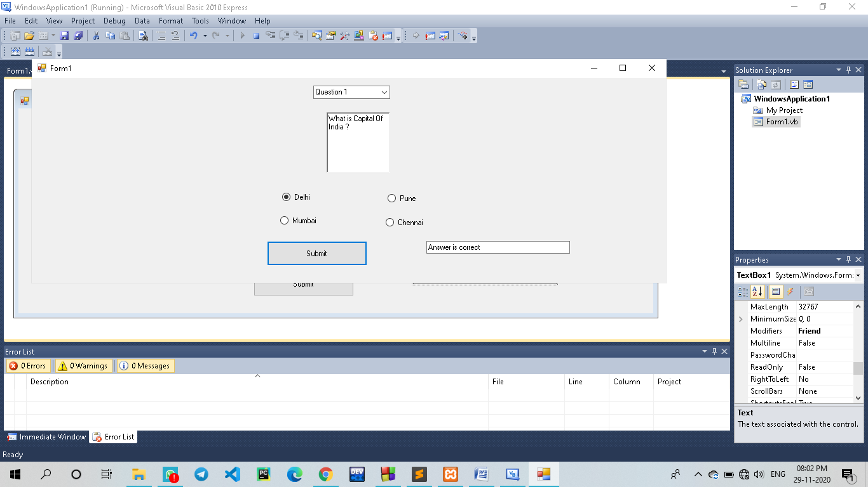

### 4.) Write a Vb.net program to accept number from user into the TextBox. Calculate the square root of that number also convert the entered number into binary number and display result into the Message Box.

Code:

Public Class Form1

Private Sub Button1_Click(sender As System.Object, e As System.EventArgs) Handles Button1.Click

Dim n As Integer

Dim sqr As Double

Dim rm As Integer

Dim str1 As String

n = CInt(TextBox1.Text)

sqr = n * n

While n

rm = n Mod 2

str1 = str1 & rm

n = n \ 2

End While

MessageBox.Show("Square Root :" & sqr & " Binary Number : " & str1)

StrReverse(str1)

End Sub

End Class

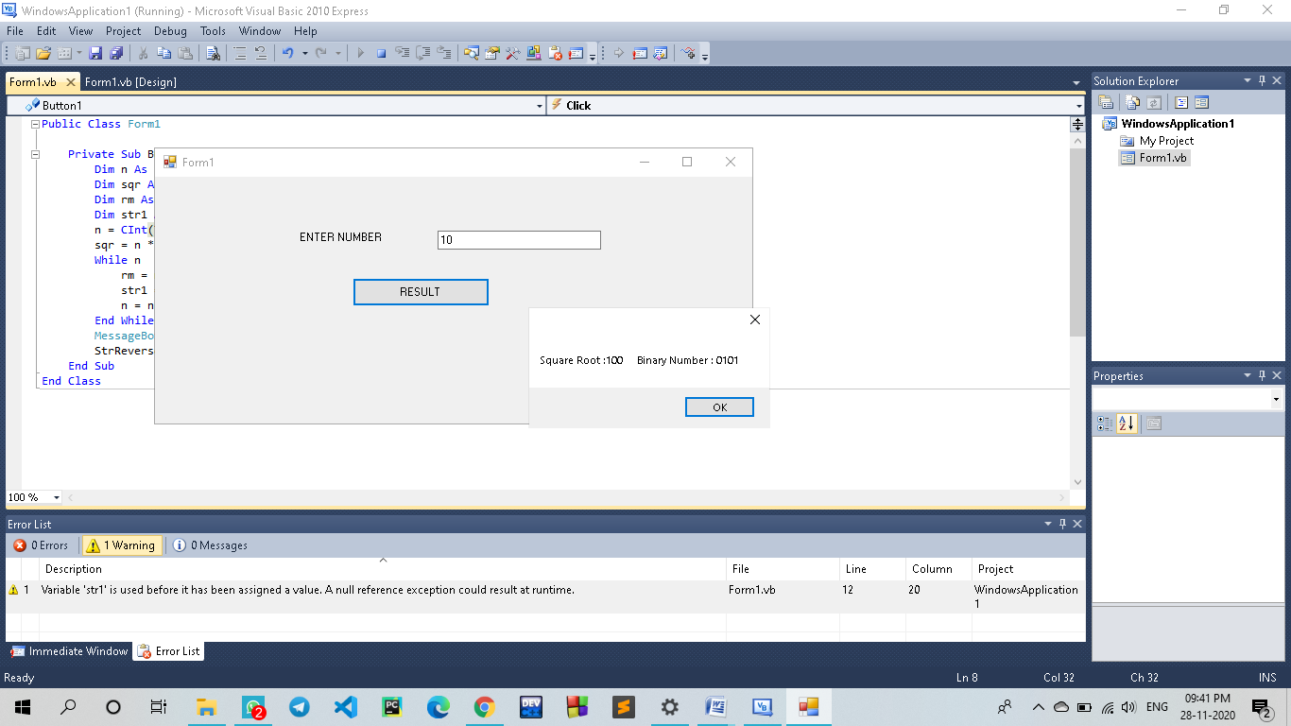

**5.)Write VB program to find octal, hexadecimal, binary of given decimal number**

**Code:**

Public Class Form1

Dim n As Integer

Dim bs As String

Private Sub Button2_Click(sender As System.Object, e As System.EventArgs) Handles Button2.Click

TextBox1.Text = " "

TextBox2.Text = " "

TextBox3.Text = " "

TextBox4.Text = " "

End Sub

Private Sub Button1_Click(sender As System.Object, e As System.EventArgs) Handles Button1.Click

n = Val(TextBox1.Text)

bs = " "

While n > 0

bs = n Mod 2 & bs

n = n / 2

End While

TextBox2.Text = bs

n = Val(TextBox1.Text)

TextBox3.Text = Oct(n)

TextBox4.Text = Hex(n)

End Sub

End Class

**Output:-**

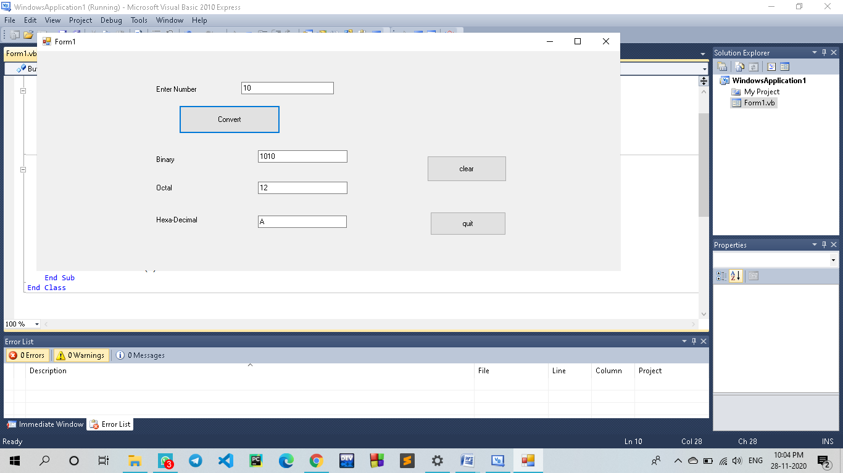

**6.)Write a program to find the sum, subtraction and Multiplication of *two numbers using the function***

***Code:***

Public Class Form1

Dim a As Integer

Dim b As Integer

Private Sub Form1_Load(sender As System.Object, e As System.EventArgs) Handles MyBase.Load

End Sub

Private Sub Button1_Click(sender As System.Object, e As System.EventArgs) Handles Button1.Click

a = TextBox1.Text

b = TextBox2.Text

TextBox3.Text = a + b

End Sub

Private Sub Button2_Click(sender As System.Object, e As System.EventArgs) Handles Button2.Click

a = TextBox1.Text

b = TextBox2.Text

TextBox3.Text = a - b

End Sub

Private Sub Button3_Click(sender As System.Object, e As System.EventArgs) Handles Button3.Click

a = TextBox1.Text

b = TextBox2.Text

TextBox3.Text = a / b

End Sub

Private Sub Button4_Click(sender As System.Object, e As System.EventArgs) Handles Button4.Click

a = TextBox1.Text

b = TextBox2.Text

TextBox3.Text = a * b

End Sub

End Class

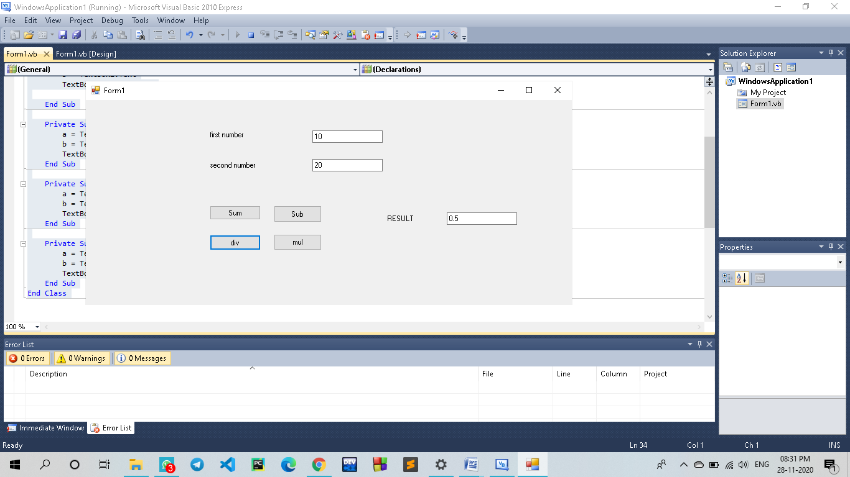

**7.)Write a program to reverse a number and check whether the given number is palindrome or not.**

Code:

Module Module1

Sub Main()

Dim r, n, temp, sum As Integer

n = 454 ' enter number

sum = 0

temp = n

While n > 0

r = n Mod 10

'getting remainder

sum = (sum * 10) + r

n = n / 10

End While

If temp = sum Then

Console.WriteLine("palindrome number")

Else

Console.WriteLine("not palindrome")

End If

Console.ReadLine()

End Sub

End Module

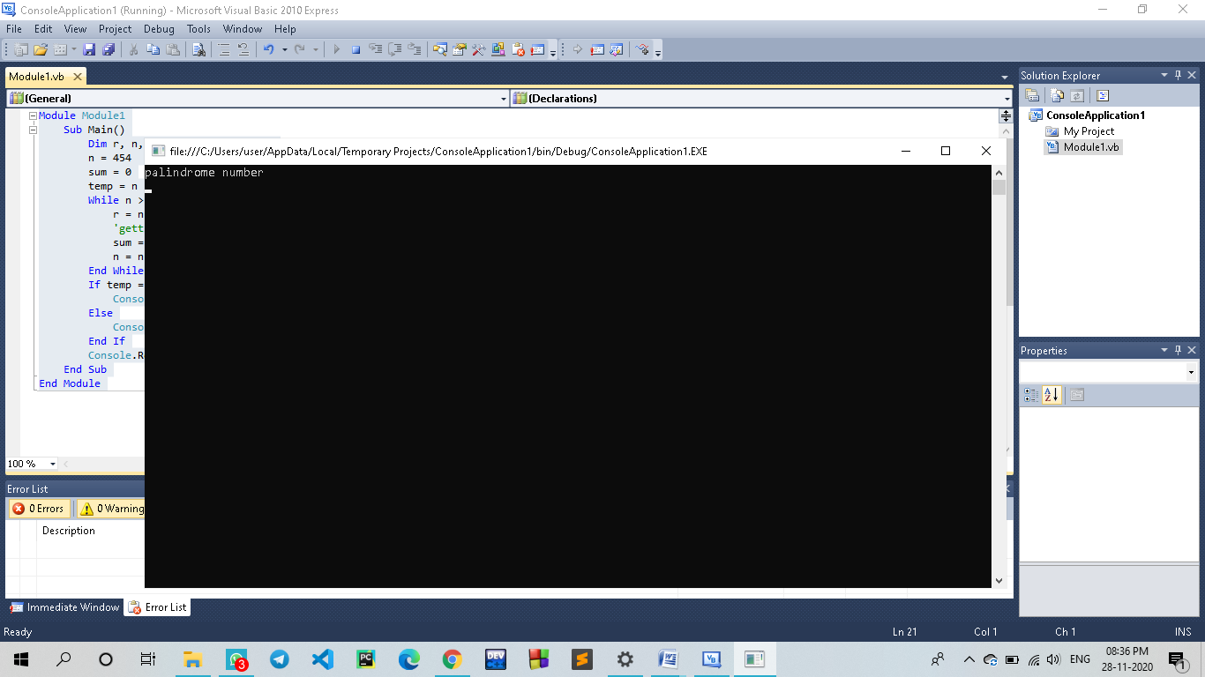

**8.)Create a program to find the Area and Parameter of a rectangle using the class and object in VB.NET.**

**Code:-**

Public Module Exercise

Friend Class Rectangle

Public Length As Double

Public Height As Double

Function Perimeter() As Double

Return (Length + Height) * 2

End Function

Function Area#()

Return Length * Height

End Function

End Class

Public Function Main() As Integer

Dim Recto As Rectangle

Recto = New Rectanglec

Recto.Length = 42.58 : Recto.Height = 28.08

MsgBox("=-= Rectangle Characteristics =-=" & vbCrLf & _

"Length: " & vbTab & vbTab & Recto.Length & vbCrLf & _

"Height: " & vbTab & vbTab & Recto.Height & vbCrLf & _

"Perimeter: " & vbTab & Recto.Perimeter() & vbCrLf & _

"Area: " & vbTab & vbTab & Recto.Area())

Return 0

End Function

End Module

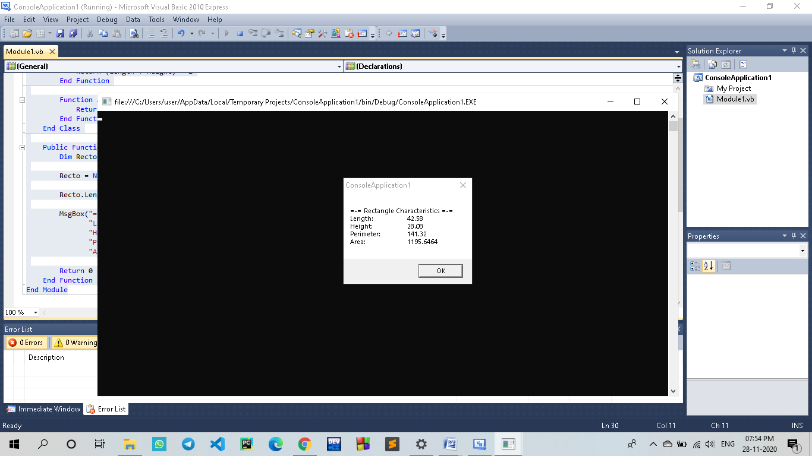

**9.)Create a program to define the default constructor and parameterized constructor in a VB.NET programming language.**

**Program:-**

**Default constructor:-**

**Code:-**

Module Module1

Class User

Public name, location As String

Public Sub New()

name = "SAGAR SATPUTE"

location = "Pipla (da.b)"

End Sub

End Class

Sub Main()

Dim user As User = New User()

Console.WriteLine(user.name)

Console.WriteLine(user.location)

Console.WriteLine("Press Enter Key to Exit..")

Console.ReadLine()

End Sub

End Module

**Code:-**

**Parameterized constructor:-**

Module Module1

Class User

Public name, location As String

Public Sub New(ByVal a As String, ByVal b As String)

name = a

location = b

End Sub

End Class

Sub Main()

Dim user As User = New User("sagar satpute", "pipla (da.b)")

Console.WriteLine(user.name)

Console.WriteLine(user.location)

Console.WriteLine("Press Enter Key to Exit..")

Console.ReadLine()

End Sub

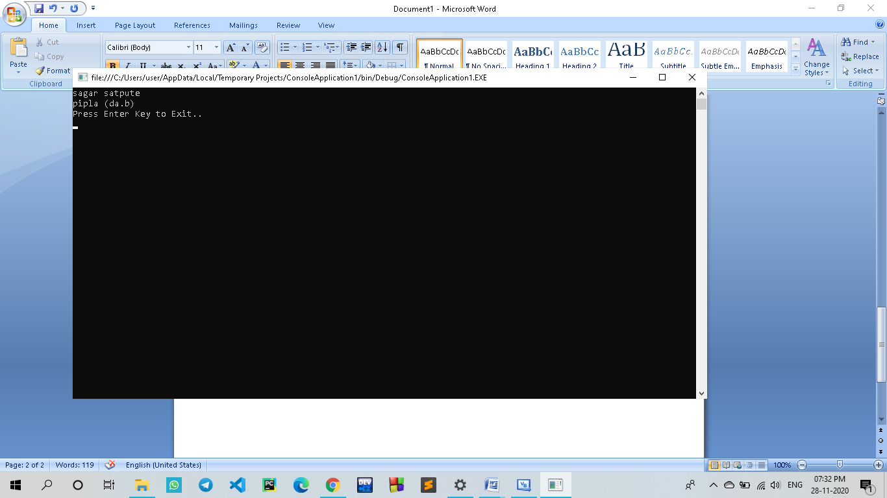

**10.)Create a program to understand the concept of Inheritance in VB.NET**

Code:

Public Class User

Public Name As String

Private Location As String

Public Sub New()

Console.WriteLine("Base Class Constructor")

End Sub

Public Sub GetUserInfo(ByVal loc As String)

Location = loc

Console.WriteLine("Name: {0}", Name)

Console.WriteLine("Location: {0}", Location)

End Sub

End Class

Public Class Details

Inherits User

Public Age As Integer

Public Sub New()

Console.WriteLine("Child Class Constructor")

End Sub

Public Sub GetAge()

Console.WriteLine("Age: {0}", Age)

End Sub

End Class

Class Program

Public Shared Sub Main(ByVal args As String())

Dim d As Details = New Details()

d.Name = "Sagar Satpute"

d.Age = 20

d.GetUserInfo("pipla (da.b)")

d.GetAge()

Console.WriteLine(vbLf & "Press Any Key to Exit..")

Console.ReadLine()

End Sub

End Class

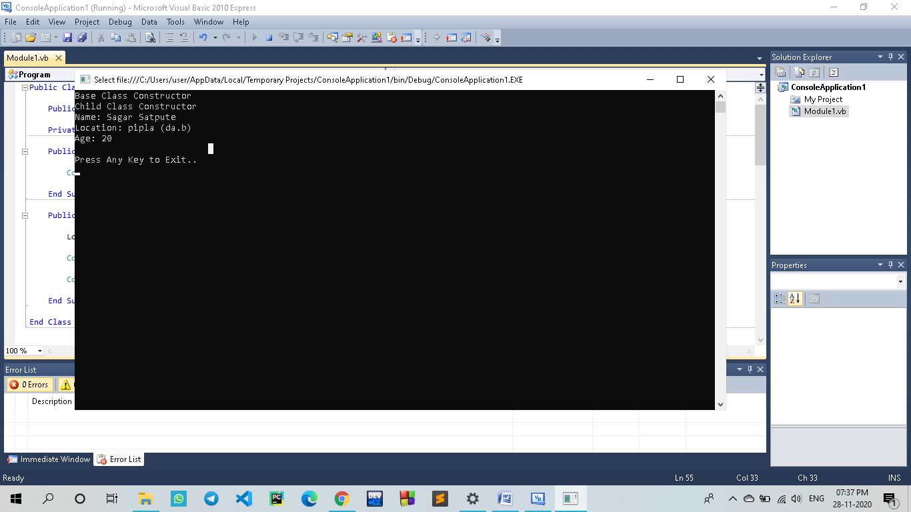

**11.) Create and implement an instance using a class in VB.NET**

**Code:-**

Module mybox

Class Box

Public length As Double

Public breadth As Double

Public height As Double

End Class

Sub Main()

Dim Box1 As Box = New Box()

Dim Box2 As Box = New Box()

Dim volume As Double = 0.0

Box1.height = 5.0

Box1.length = 6.0

Box1.breadth = 7.0

Box2.height = 10.0

Box2.length = 12.0

Box2.breadth = 13.0

volume = Box1.height * Box1.length * Box1.breadth

Console.WriteLine("Volume of Box1 : {0}", volume)

volume = Box2.height * Box2.length * Box2.breadth

Console.WriteLine("Volume of Box2 : {0}", volume)

Console.ReadKey()

End Sub

End Module

**Output:**

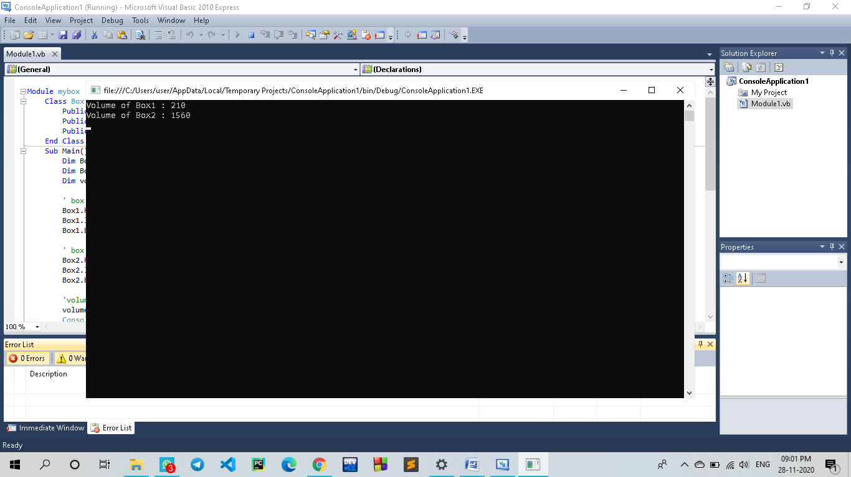

**12.) Create a program to handle an exception using the Try, Catch, and Finally keywords for dividing a number by zero in VB.NET programming.**

Code:-

Module Module1

Sub divisionFunction(ByVal n1 As Integer, ByVal n2 As Integer)

Dim answer As Integer

Try

answer = n1 \ n2

Catch ex As DivideByZeroException

Console.WriteLine("Exception: {0}", ex)

Finally

Console.WriteLine("Answer is: {0}", answer)

End Try

End Sub

Sub Main()

divisionFunction(4, 0)

Console.ReadKey()

End Sub

End Module

Output:-

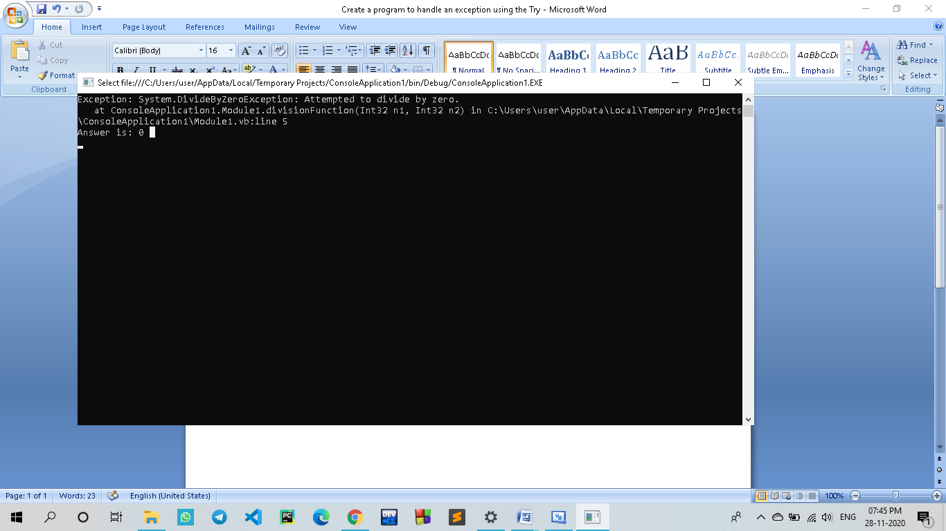

**13.)Create a program to display the multiple windows in the**[**VB.NET**](https://www.javatpoint.com/vb-net)**Windows Forms.**

Code:-

Public Class Form1

Private Sub Firstpage(sender As System.Object, e As System.EventArgs) Handles MyBase.Load

End Sub

Private Sub Button1_Click(sender As System.Object, e As System.EventArgs) Handles Button1.Click

Dim SecondForm As New frmSecond

SecondForm.Show()

End Sub

End Class

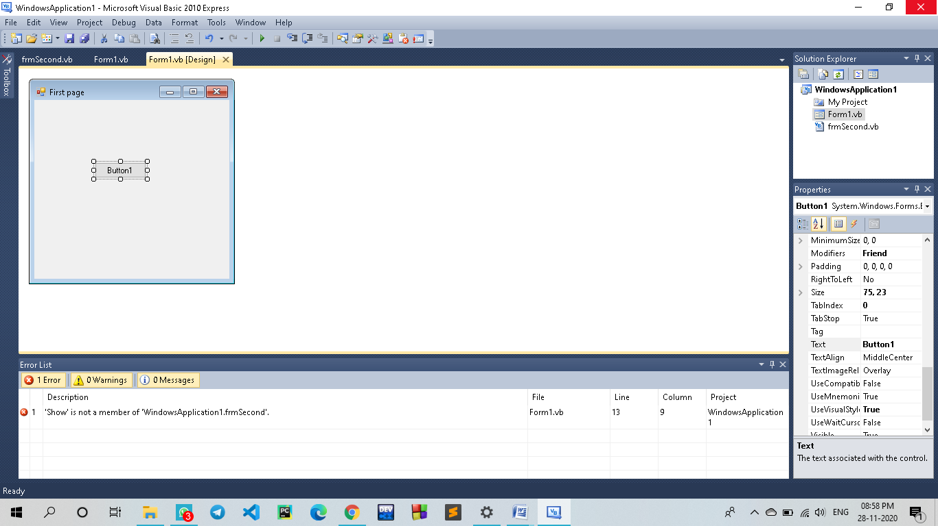

**14.) Create a simple program to understand the use of Timer Control in the VB.NET Windows Forms**

**Code:**

Public Class TimerProgram

Private Sub TimerProgram_Load(sender As Object, e As EventArgs) Handles MyBase.Load

Me.Text = "BCA" 'Set the title for a Windows Form

Label1.Text = "WELCOME TO Visual Basic "

TextBox1.Text = 1

Timer1.Enabled = True

Button1.Text = "Start"

Button1.BackColor = Color.Blue

Button1.ForeColor = Color.White

Button2.Text = "Stop"

Button2.BackColor = Color.Red

Button2.ForeColor = Color.White

Timer1.Start()

Timer1.Interval = 600 'set the time interval

End Sub

Private Sub Timer1_Tick(sender As Object, e As EventArgs) Handles Timer1.Tick

If Label1.ForeColor = Color.Red Then

Label1.ForeColor = Color.Blue

ElseIf Label1.ForeColor = Color.Blue Then

Label1.ForeColor = Color.Red

End If

TextBox1.Text = TextBox1.Text + 1 'Incremenet the TextBox1 by 1

End Sub

Private Sub Button2_Click(sender As Object, e As EventArgs) Handles Button2.Click

Timer1.Stop() ' Stop the timer

End Sub

Private Sub Button1_Click(sender As Object, e As EventArgs) Handles Button1.Click

Timer1.Start() 'Start the timer

End Sub

End Class

**Output:**

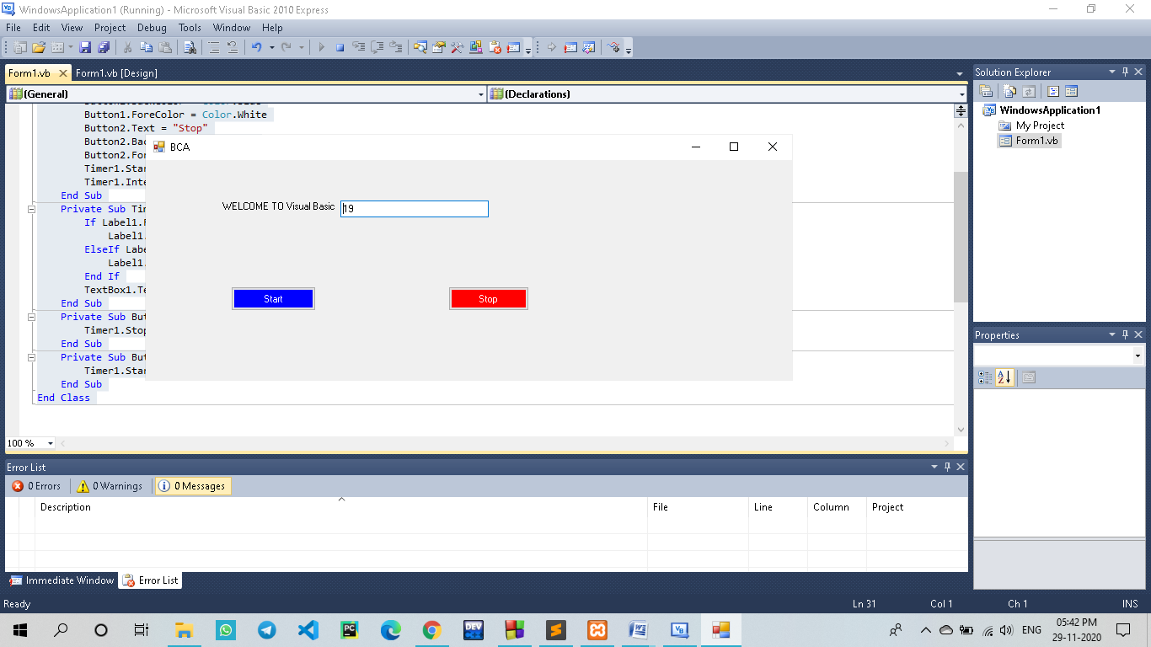

**15.) Write VB program that moves image left or right using click event.**

Code:-